**2nd Lab - Two-Router Interconnected Network with Hierarchical Switch and PC Distribution**

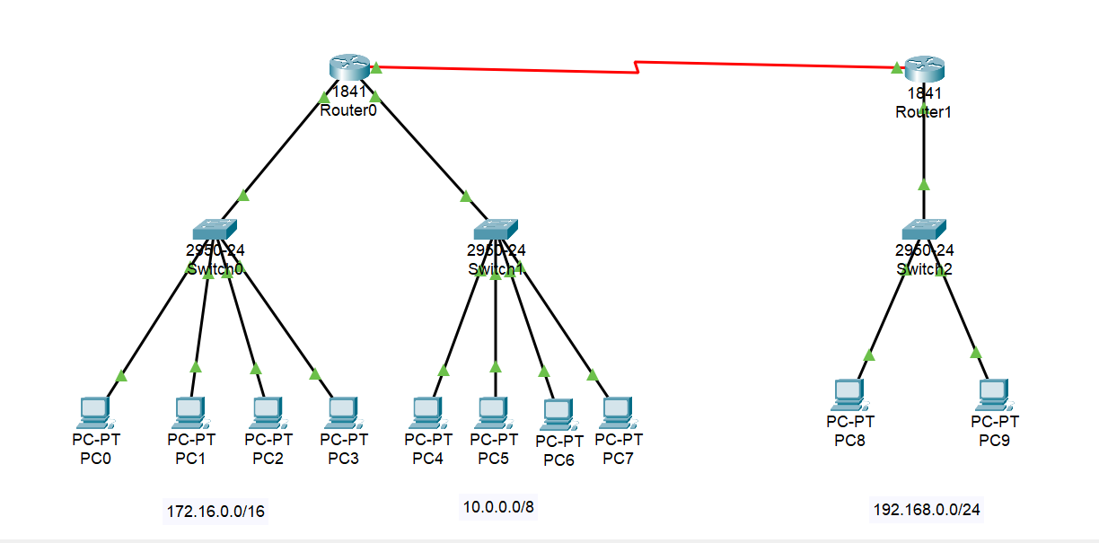**Topology:**

1. **Network Overview**

This network consists of two routers, three switches, and ten PCs. The devices are configured across three subnets:  
- 172.16.0.0/16 (connected to Router1 via Switch1, 4 PCs)  
- 10.0.0.0/8 (connected to Router1 via Switch2, 4 PCs)  
- 192.168.0.0/24 (connected to Router2 via Switch3, 2 PCs)

1. **PC Configuration Instructions**

To configure each PC:  
1. Click on the PC.  
2. Go to the 'Desktop' tab.  
3. Select 'IP Configuration'.  
4. Enter the respective IP address, subnet mask, and default gateway.

1. **IP Addressing Scheme**

**Router1:**

FastEthernet 0/0: 172.16.0.1 (to Switch1)

FastEthernet 0/1: 10.0.0.1 (to Switch2)

Serial 0/0/0: 192.168.1.1 (to Router2)

**Router2:**

Serial 0/0/1: 192.168.1.2 (to Router1)

FastEthernet 0/0: 192.168.0.1 (to Switch3)

**PCs:**

PC1-PC4: 172.16.0.2 to 172.16.0.5, Gateway: 172.16.0.1

PC5-PC8: 10.0.0.2 to 10.0.0.5, Gateway: 10.0.0.1

PC9-PC10: 192.168.0.2 to 192.168.0.3, Gateway: 192.168.0.1

1. **CLI Configuration Commands**
2. **Router1 Configuration:**

Router> enable

Router# configure terminal

Router(config)# hostname Router1

Router1(config)# interface fastethernet 0/0

Router1(config-if)# ip address 172.16.0.1 255.255.0.0

Router1(config-if)# no shutdown

Router1(config-if)# interface fastethernet 0/1

Router1(config-if)# ip address 10.0.0.1 255.0.0.0

Router1(config-if)# no shutdown

Router1(config-if)# interface serial 0/0/0

Router1(config-if)# ip address 192.168.1.1 255.255.255.0

Router1(config-if)# clock rate 250000

Router1(config-if)# no shutdown

Router1(config-if)# exit

Router1(config)# ip route 192.168.0.0 255.255.255.0 192.168.1.2

Router1(config)# Ctrl + Z

Router1# write

1. **Router2 Configuration:**

Router> enable

Router# configure terminal

Router(config)# hostname Router2

Router2(config)# interface serial 0/0/1

Router2(config-if)# ip address 192.168.1.2 255.255.255.0

Router2(config-if)# no shutdown

Router2(config-if)# interface fastethernet 0/0

Router2(config-if)# ip address 192.168.0.1 255.255.255.0

Router2(config-if)# no shutdown

Router2(config-if)# exit

Router2(config)# ip route 172.16.0.0 255.255.0.0 192.168.1.1

Router2(config)# ip route 10.0.0.0 255.0.0.0 192.168.1.1

Router2(config)# Ctrl + Z

Router2# write